

# **BlueWaters Travel Agency DBMS Project**

Oscar Brugal: [oscar.davila@baruchmail.cuny.ed](mailto:oscar.davila@baruchmail.cuny.edu)u

Thy Bui: [anhthy.bui@baruchmail.cuny.edu](mailto:anhthy.bui@baruchmail.cuny.edu)

Lucy Chen: [lucy.chen2@baruchmail.cuny.edu](mailto:lucy.chen2@baruchmail.cuny.edu)

Frank DeRosa: [frank.derosa@baruchmail.cuny.edu](mailto:FRANK.DEROSA@baruchmail.cuny.edu)

Shetaz Karim: [shetaz.karim@baruchmail.cuny.edu](mailto:shetaz.karim@baruchmail.cuny.edu)

Gabriel Fernandez: [gabriel.fernandez@baruchmail.cuny.edu](mailto:gabriel.fernandez@baruchmail.cuny.edu)

CIS 9340 - NSA

Professor Luisa Martich

## Table of Contents

**BlueWaters Travel Agency DBMS Project** **1**

Table of Contents 2

Part 1: Project Proposal 3

Business Problem 3

Proposed Solution 4

Identification of the Information Needs 4

Project Roles 4

Part 2: System Analysis and ER Modeling 5

Business Requirements 5

ER Modeling 6

Our Entities 7

ER Modeling Relationships 8

Assumptions 8

Part 3. Logical and Physical Modeling 10

Relational Model, Dependencies, and Normalization 10

Review of normal forms 10

Logical and Physical Modeling Assumptions 12

Part 4. Physical Database Implementation in Microsoft Access 18

Part 5. Application implementation in MS Access 29

Forms 29

Reports 31

Queries 33

Part 6: Narrative Conclusion 36

a) The group's experience with the project 36

b) If the proposed benefits can be realized by the new system 36

c) Any final comments and conclusions 36

Appendix A: Meeting Logs 37

Appendix B: Group Team Project Participation 40

Appendix C: Reference 41

## Part 1: Project Proposal

### 

**BlueWaters Travel Agency** is an online travel agency that sells travel and tourism-related services to its customers. BlueWaters' mission is to find the best deals for its customers and provide excellent customer service.

Also, the agency specializes in travel packages to Central America and the Caribbean that include (ground transportation, air ticket, and all-inclusive resorts). They provide promotions for their packages. They would like to collect data about their customers (user profile) to improve their offerings.

### Business Problem

BlueWaters has been using spreadsheets to track its services and travel packages.

In 2021, Central America and the Caribbeanbecame popular destinations for Americans wanting a break from remote working and pandemic restrictions. As a result, BlueWater's customer base has increased faster than expected. Using spreadsheets to keep up with the demand and gather customer data is becoming challenging. The business encountered double booking problems. BlueWaters’ file-based system was not able to keep up with new reservations and cancellations. A lot of back and forth communication is needed among our employees to prevent overbooking. This creates downtime, increases customer waiting time, and reduces customer satisfaction.

BlueWaters demands a database system that allows the business to keep track of real-time inventory and quickly respond to customers. BlueWaters would like to have a system that could be scalable to manage their data and improve their data integrity. With an expanding customer base, BlueWaters also wants to take advantage of customer data to tap the right target customer, drive business growth and improve customer experience.

### Proposed Solution

BlueWaters would benefit from a database management system (DBMS)to manage and keep the integrity of their data. Also, they will benefit from applications (forms, queries, and reports) to process their data to drive business growth and customer satisfaction. Since BlueWaters pays for Microsoft Office and it is a small travel agency, Microsoft Access Database will be sufficient to accomplish their business objectives.

Identification of the Information Needs

* Services that BlueWaters provides
* Customer information that they will collect
* Preference of their customers (profile)
* Travel packages offered
* Payment methods accepted

### Project Roles

* Project Manager **(Frank)**
* Project Presentation **(Frank)**
* System Analysis **(Shetaz)**
* ER Modeling (Conceptual) **(Oscar)**
* Logical Model Designer **(Gabriel)**
* Normalization **(Gabriel)**
* Documentation/Final Report **(Lucy)**
* Physical Designer (Implementation) **(Lucy, Gabriel)**
* Application Developer (Navigation, Forms, and Reports) **(Shetaz)**
* Queries **(Thy, Oscar)**

## Part 2: System Analysis and ER Modeling

### Business Requirements

- BlueWaters specializes in travel packages to Central America and the Caribbean

- BlueWaters has partnered with multiple suppliers across different destinations to provide customers with the best package

- Customers can create a Profile with BlueWaters with their personal information

- Customers can choose from a variety of packages and make reservations for their preferred package online

- Customers can track the status of their reservation online

- Customers can pay with PayPal, Credit card, or Debit Card

- Management can run queries to know many times each supplier has been used

- Management can combine different suppliers to create new packages (with form)

### ER Modeling

### 

### 

### 

### 

## 

### Our Entities

1. Customer
2. Profile
3. Reservation
4. Itinerary
5. Companion
6. Status
7. Package
8. Supplier
9. PaymentMethod
10. City
11. Country
12. Region
13. ServiceType

Interception Relations:

1. ReservationCompanion
2. PackageSupplier
3. CitySupplier

### 

### ER Modeling Relationships

### Assumptions

* You can only use a PaymentMethod for and Reservation
* A Customer needs a Profile. If the Customer does not create a Profile, a Profile is created automatically
* Reservations can only have a Customer with one or many companions
* A Customer can only use a PaymentMethod for a Reservation
* Package prices are per person
* A Supplier is associated with one ServiceType
* Itinerary contains three hyperlinks to the pdf files of each service contained a package, which is dependent of the primary key itineraryID

| Entities | Multiplicity and relationship sentences |
| --- | --- |
| Customer and Profile | * A Customer has a Profile (1..1) * A Profile belongs to a Customer (1..1) |
| Customer and Reservation | * A Customer has one or many Reservations (1..*) * A Reservation can have only a Customer (1..1) |
| Reservation and Status | * A Reservation has only a Status (1..1) * A Status can have one or many Reservations (1..*) |
| Reservation and PaymentMethod | * A Reservation has only a PaymentMethod (1..1) * A PaymentMethod can have one or many Reservations (1..*) |
| Reservation and Itinerary | * A Reservation has only a Itinerary (1..1) * A Itinerary belongs to only a Reservations (1..1) |
| Reservation and Companion | * A Reservation has one or many Companions (1..*) * A Companion belongs to one or many Reservations (1..*) |
| Reservation and Package | * A Reservation can have only a Package (1..1) * A Package belongs to one or many Reservations (1..*) |
| Supplier and Package | A Supplier is associated with one or many Packages (1..*)  A Package contains one or many Suppliers (1..*) |
| Supplier and ServiceType | A Supplier is associated with one ServiceType (1..1)  A ServiceType belongs to one or many Suppliers (1..*) |
| Supplier and City | * A Supplier can be located in one or many Cities (1..*) * A City can have one or many Suppliers (1..*) |
| City and Country | * A City is located in only one Country (1..1) * A Country has one or many Cities (1..*) |
| Country and Region | * A Country is located in only one Region (1..*) * A Region can have one or many Countries (1..*) |

## 

### 

## Part 3. Logical and Physical Modeling

### Relational Model, Dependencies, and Normalization

Normalization was implemented during the logical modeling stage. We chose to apply normalization using the two approaches that we learned in the book. First, we use normalization as a validation technique to check the structure of our set of relations. After translating the ER model to the relational model (logical), we listed the functional dependencies and reviewed if the relations follow each normal form. Second, we used the bottom-up technique when we created the set of relations. For instance, during the ER modeling stage, we realized that we could split some entities to maintain normalization such as City, Country, Region, PaymentMethod, and Status.

Most of our tables are normalized to 4NF. However, the "Customer" and "Supplier" were not normalized beyond 2NF to facilitate the usability of the application. Also, we implemented a lookup field for "Gender" in the physical implementation to achieve the normalization of the table "Profile."

### Logical and Physical Modeling Assumptions

* A customer can have only a Tel
* A customer can have only an Email
* A supplier can have only a Tel
* A supplier can have only an Email
* A supplier can have only one Website

The entities Customer and Supplier were not normalized beyond 2NF to facilitate the usability of the application.

| Relation  Functional dependencies  Normalization | **Customer** (CustomerID {PK}, FirstName, LastName, Tel, Email, Street, City, State, ZipCode)  **Primary key** CustomerID  **Alternate Key** Tel  **Alternate Key** Email  CustomerID→ FirstName, LastName, Tel, Email, Street, City, State, ZipCode  Tel → FirstName, LastName, Email, Street, City, State, ZipCode  Email→ FirstName, LastName, Tel, Street, City, State, ZipCode   |  | 1NF |  | 2NF |  | 3NF |  | BCNF |  | 4NF |  | 5NF | | --- | --- | --- | --- | --- | --- | --- | --- | --- | --- | --- | --- |   There is transitive dependency |
| --- | --- | --- | --- | --- | --- | --- | --- | --- | --- | --- | --- | --- | --- |

| Relation  Functional dependencies  Normalization | **Profile** (ProfileID {PK}, CreationDate, DOB, FamilySize, Gender, CustomerID {FK})  **Primary key** ProfileID  **Foreign Key** CustomerID **references** Customer(CustomerID)  ProfileID→CreationDate, DOB, FamilySize, Gender, CustomerID   |  | 1NF |  | 2NF |  | 3NF |  | BCNF |  | 4NF |  | 5NF | | --- | --- | --- | --- | --- | --- | --- | --- | --- | --- | --- | --- |   Gender was implemented as a lookup field in the physical implementation. |
| --- | --- | --- | --- | --- | --- | --- | --- | --- | --- | --- | --- | --- | --- |

| Relation  Functional dependencies  Normalization | **Reservation** (ReservationID {PK}, ReservationDate, Comments,NoofTravelers, CustomerID {FK}, StatusID {FK}, PaymentMethodID {FK}, PackageID {FK}, ItineraryID {FK})  **Primary key** ReservationID  **Foreign Key** CustomerID **references** Customer(CustomerID)  **Foreign Key** StatusID **references** Status(StatusID)  **Foreign Key** PaymentMethodID **references** PaymentMethod (PaymentMethodID )  **Foreign Key** PackageID **references** Package(PackageID)  **Foreign Key** ItineraryID **references** Itinerary( ItineraryID)  ReservationID→ReservationDate, Comments, NoofTravelers, CustomerID, StatusID, PaymentMethodID, PackageID, ItineraryID   |  | 1NF |  | 2NF |  | 3NF |  | BCNF |  | 4NF |  | 5NF | | --- | --- | --- | --- | --- | --- | --- | --- | --- | --- | --- | --- | |
| --- | --- | --- | --- | --- | --- | --- | --- | --- | --- | --- | --- | --- | --- |

| Relation  Functional dependencies  Normalization | **Status** (StatusID {PK}, Status)  **Primary key** StatusID  StatusID→ Status   |  | 1NF |  | 2NF |  | 3NF |  | BCNF |  | 4NF |  | 5NF | | --- | --- | --- | --- | --- | --- | --- | --- | --- | --- | --- | --- | |
| --- | --- | --- | --- | --- | --- | --- | --- | --- | --- | --- | --- | --- | --- |

| Relation  Functional dependencies  Normalization | **PaymentMethod** (PaymentMethodID {PK}, Type)  **Primary key** PaymentMethodID  PaymentMethodID→ Type   |  | 1NF |  | 2NF |  | 3NF |  | BCNF |  | 4NF |  | 5NF | | --- | --- | --- | --- | --- | --- | --- | --- | --- | --- | --- | --- | |
| --- | --- | --- | --- | --- | --- | --- | --- | --- | --- | --- | --- | --- | --- |

| Relation  Functional dependencies  Normalization | **Companion** (CompanionID {PK}, FirstName, LastName, DOB)  **Primary key** CompanionID  CompanionID→FirstName, LastName, DOB   |  | 1NF |  | 2NF |  | 3NF |  | BCNF |  | 4NF |  | 5NF | | --- | --- | --- | --- | --- | --- | --- | --- | --- | --- | --- | --- | |
| --- | --- | --- | --- | --- | --- | --- | --- | --- | --- | --- | --- | --- | --- |

| Relation  Functional dependencies  Normalization | **ReservationCompanion** (ReservationID {PK, FK}, CompanionID {PK, FK})  **Primary key** ReservationID, CompanionID  **Foreign Key** ReservationID **references** Reservation(ReservationID)  **Foreign Key** CompanionID **references** Companion( CompanionID )  No applicable: **Composite key** (ReservationID, CompanionID)   |  | 1NF |  | 2NF |  | 3NF |  | BCNF |  | 4NF |  | 5NF | | --- | --- | --- | --- | --- | --- | --- | --- | --- | --- | --- | --- | |
| --- | --- | --- | --- | --- | --- | --- | --- | --- | --- | --- | --- | --- | --- |

| Relation  Functional dependencies  Normalization | **Package** (PackageID {PK}, Name, Price, Description, NoDays}  **Primary key** PackageID  **PackageID**→ Name, Price, Description, NoDays   |  | 1NF |  | 2NF |  | 3NF |  | BCNF |  | 4NF |  | 5NF | | --- | --- | --- | --- | --- | --- | --- | --- | --- | --- | --- | --- | |
| --- | --- | --- | --- | --- | --- | --- | --- | --- | --- | --- | --- | --- | --- |

| Relation  Functional dependencies  Normalization | **Supplier** (SupplierID {PK}, Name, Tel, Email, Website, Comments, ServiceTypeID {FK})  **Primary key** SupplierID  **Alternate Key** Tel  **Alternate Key** Email  **Alternate Key** Email  **Foreign Key** ServiceTypeID **references** ServiceType(ServiceTypeID )  SupplierID→Name, Tel, Email, Website, Comments, ServiceTypeID  Tel → Name, Email, Website, Comments, ServiceTypeID  Email→ Name, Tel, Website, Comments, ServiceTypeID  Website→Name, Tel, Email, Comments, ServiceTypeID   |  | 1NF |  | 2NF |  | 3NF |  | BCNF |  | 4NF |  | 5NF | | --- | --- | --- | --- | --- | --- | --- | --- | --- | --- | --- | --- |   There is transitive dependency |
| --- | --- | --- | --- | --- | --- | --- | --- | --- | --- | --- | --- | --- | --- |

| Relation  Functional dependencies  Normalization | **ServiceType** (ServiceTypeID, Name}  **Primary key** ServiceTypeID  ServiceTypeID→ Name   |  | 1NF |  | 2NF |  | 3NF |  | BCNF |  | 4NF |  | 5NF | | --- | --- | --- | --- | --- | --- | --- | --- | --- | --- | --- | --- | |
| --- | --- | --- | --- | --- | --- | --- | --- | --- | --- | --- | --- | --- | --- |

| Relation  Functional dependencies  Normalization | **PackageSupplier** (PackageID {PK, FK}, SupplierID {PK, FK})  **Primary key** PackageID, SupplierID  **Foreign Key** PackageID **references** Package(PackageID)  **Foreign Key** SupplierID **references** Supplier( SupplierID )  **Composite key** (PackageID, SupplierID)   |  | 1NF |  | 2NF |  | 3NF |  | BCNF |  | 4NF |  | 5NF | | --- | --- | --- | --- | --- | --- | --- | --- | --- | --- | --- | --- | |
| --- | --- | --- | --- | --- | --- | --- | --- | --- | --- | --- | --- | --- | --- |

| Relation  Functional dependencies  Normalization | **CitySupplier** (CityID {FK}, SupplierID {FK})  **Primary key** CityID, SupplierID  **Foreign Key** CityID **references** City (CityID)  **Foreign Key** SupplierID **references** Supplier( SupplierID )  No applicable: **Composite key** (CityID, SupplierID)   |  | 1NF |  | 2NF |  | 3NF |  | BCNF |  | 4NF |  | 5NF | | --- | --- | --- | --- | --- | --- | --- | --- | --- | --- | --- | --- | |
| --- | --- | --- | --- | --- | --- | --- | --- | --- | --- | --- | --- | --- | --- |

| Relation  Functional dependencies  Normalization | **City** (CityID {PK}, Name, CountryID {FK})  **Primary key** CityID  **Foreign Key** CountryID **references** Country (CountryID)    CityID→ Name, CountryID   |  | 1NF |  | 2NF |  | 3NF |  | BCNF |  | 4NF |  | 5NF | | --- | --- | --- | --- | --- | --- | --- | --- | --- | --- | --- | --- | |
| --- | --- | --- | --- | --- | --- | --- | --- | --- | --- | --- | --- | --- | --- |

| Relation  Functional dependencies  Normalization | **Country** (CountryID {PK}, Name, RegionID {FK})  **Primary key** CountryID  **Foreign Key** RegionID **references** Region (RegionID)    CountryID→ Name, RegionID   |  | 1NF |  | 2NF |  | 3NF |  | BCNF |  | 4NF |  | 5NF | | --- | --- | --- | --- | --- | --- | --- | --- | --- | --- | --- | --- | |
| --- | --- | --- | --- | --- | --- | --- | --- | --- | --- | --- | --- | --- | --- |

| Relation  Functional dependencies  Normalization | **Region** (RegionID {PK}, Name)  **Primary key** RegionID      RegionID→ Name   |  | 1NF |  | 2NF |  | 3NF |  | BCNF |  | 4NF |  | 5NF | | --- | --- | --- | --- | --- | --- | --- | --- | --- | --- | --- | --- | |
| --- | --- | --- | --- | --- | --- | --- | --- | --- | --- | --- | --- | --- | --- |

| Relation  Functional dependencies  Normalization | **Itinerary** {ItineraryID, ItineraryHotel, ItineraryAirline, ItineraryTransportion}  **Primary key** ItineraryID  ItineraryID→ ItineraryHotel, ItineraryAirline, ItineraryTransportion   |  | 1NF |  | 2NF |  | 3NF |  | BCNF |  | 4NF |  | 5NF | | --- | --- | --- | --- | --- | --- | --- | --- | --- | --- | --- | --- | |
| --- | --- | --- | --- | --- | --- | --- | --- | --- | --- | --- | --- | --- | --- |

### Part 4. Physical Database Implementation in Microsoft Access

1. City Table

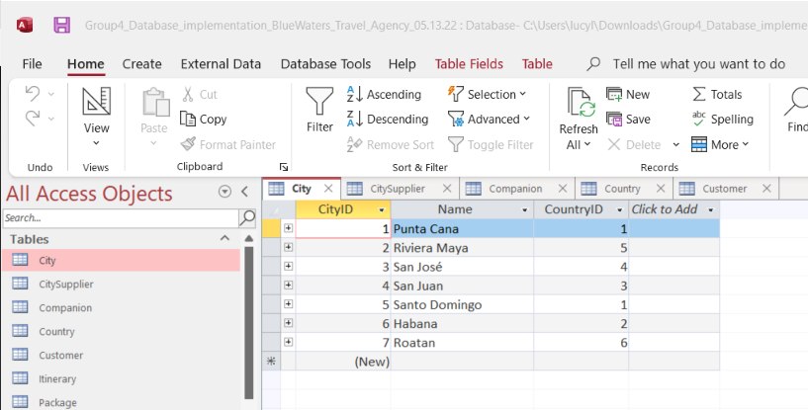

* 1. Create Statement
     1. 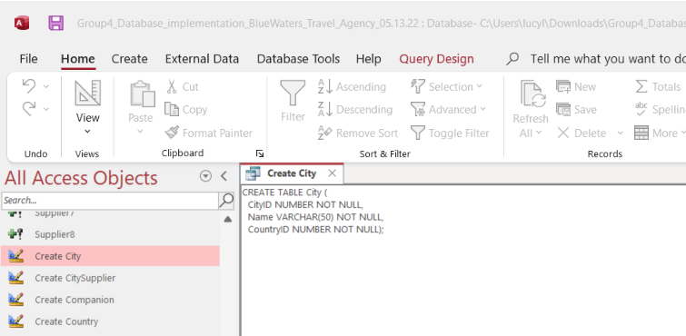
  2. Primary Key
     1. 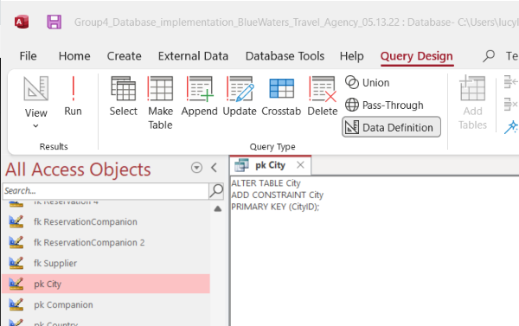
  3. Foreign Key
     1. 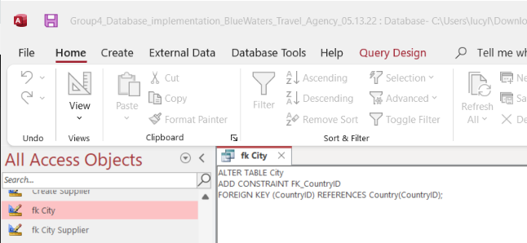
  4. Entries
     1. 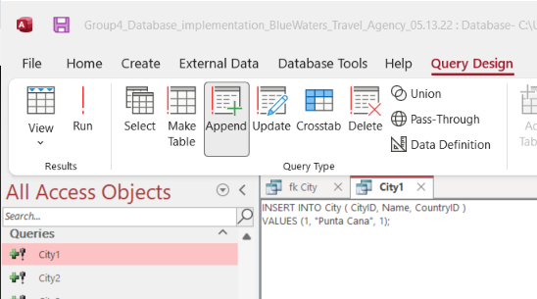
     2. 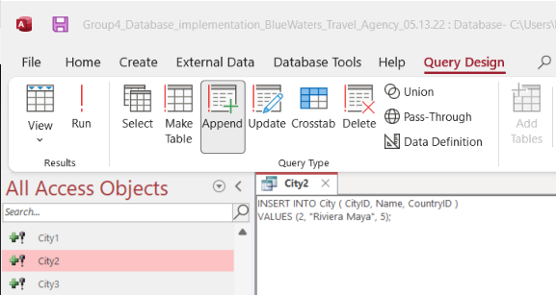

1. Country Table

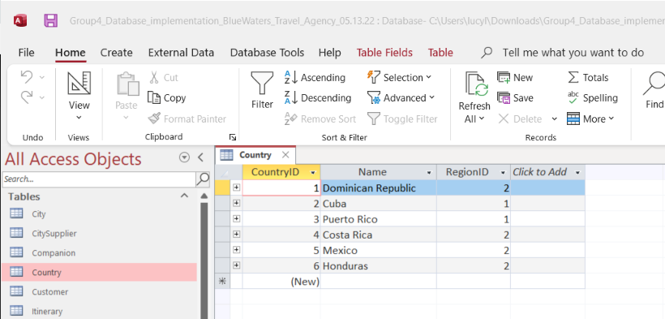

* 1. Create Statement
     1. 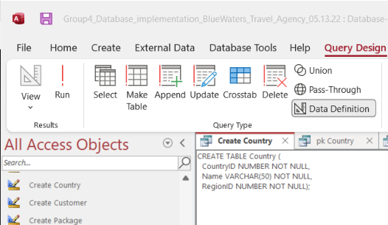
  2. Primary Key
     1. 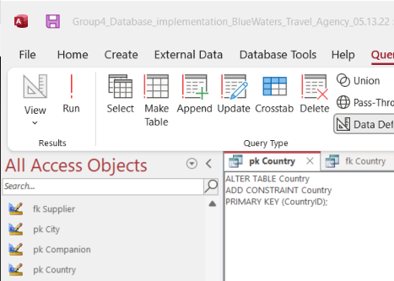
  3. Foreign Key
     1. 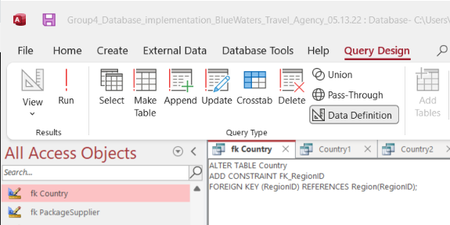
  4. Entries
     1. 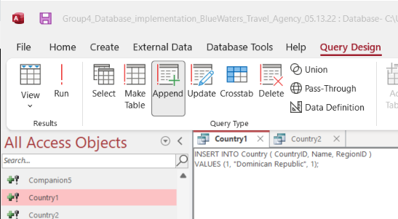
     2. 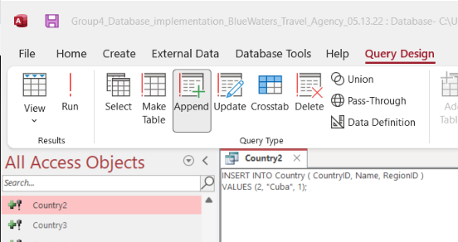

1. Companion Table

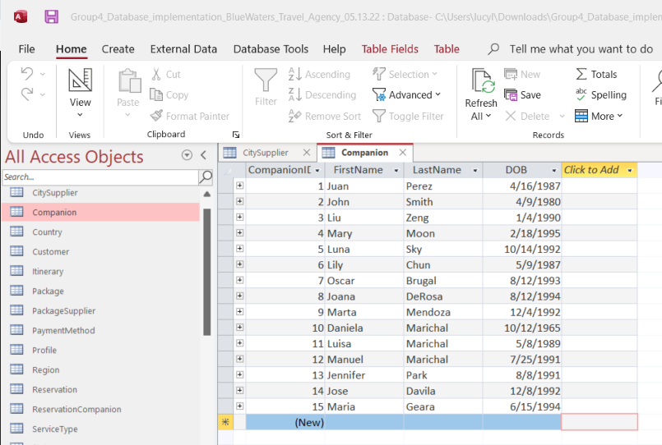

* 1. Create Statement
     1. 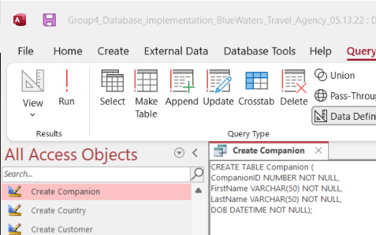
  2. Primary Key
     1. 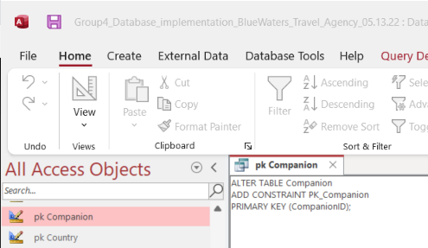
  3. Entries
     1. 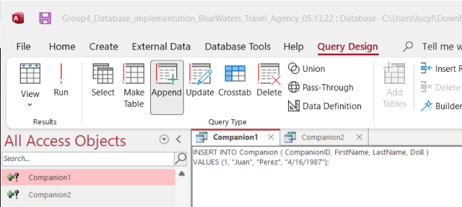
     2. 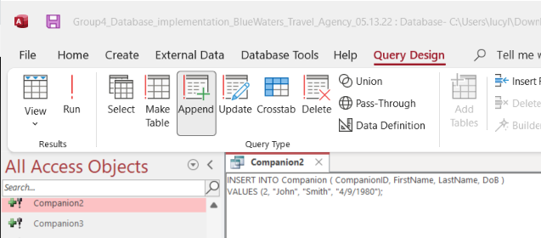

1. PackageSupplier Table

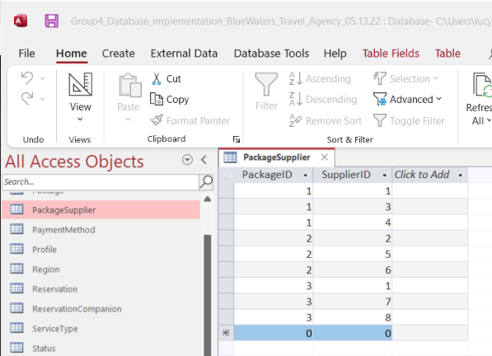

* 1. Create Statement
     1. 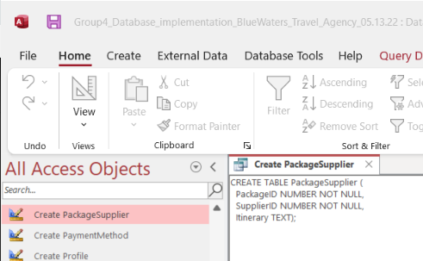
  2. Primary Key
     1. 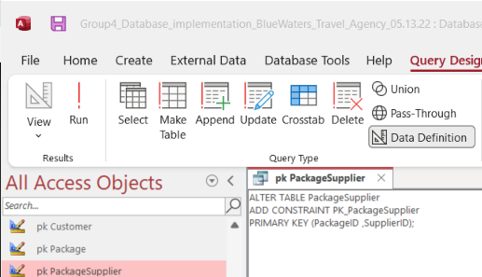
  3. Foreign Keys
     1. 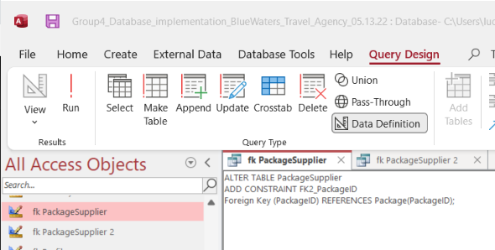
     2. 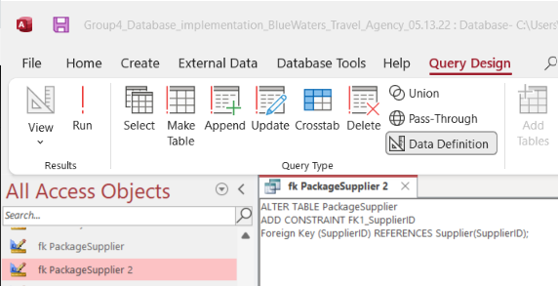
  4. Entries
     1. 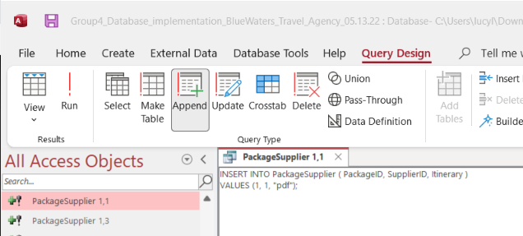
     2. 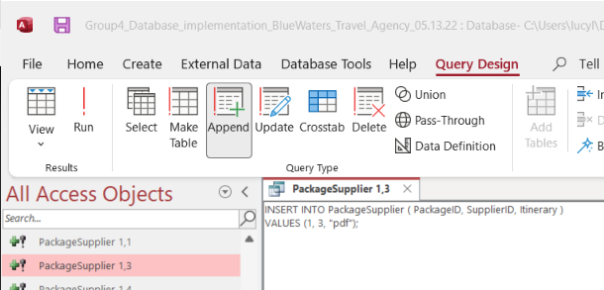

1. Supplier Table

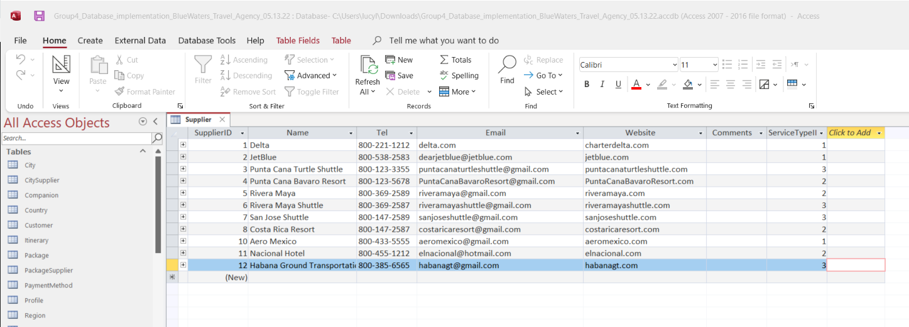

* 1. Create Statement
     1. 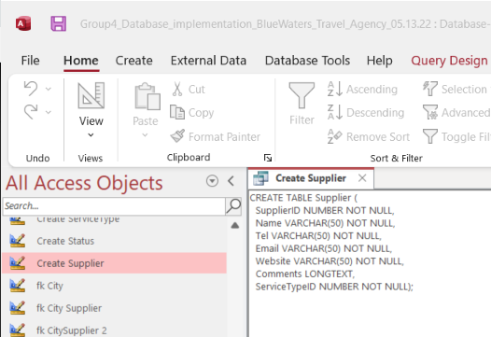
  2. Primary Key
     1. 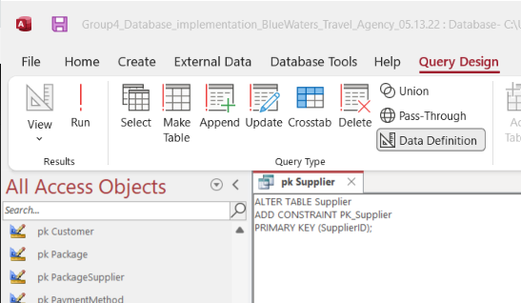
  3. Foreign Key
     1. 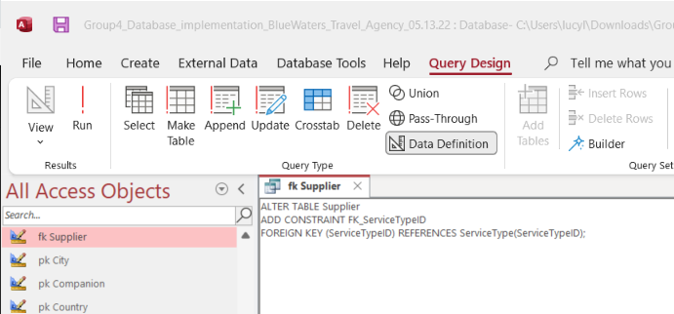
  4. Entries
     1. 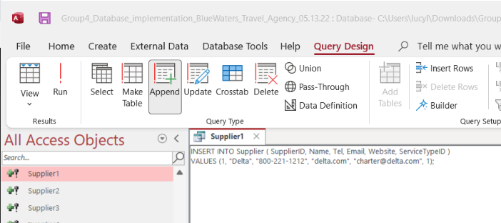
     2. 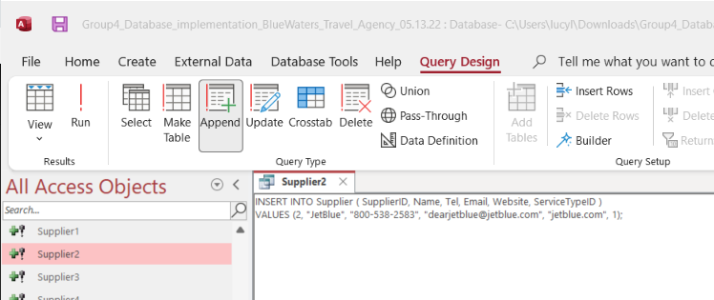

## Part 5. Application Implementation in MS Access

### 

### Forms

**Customer Profile Form** is available on BlueWaters website for customers to create an initial profile with us with their personal details including family size, before making any reservations.

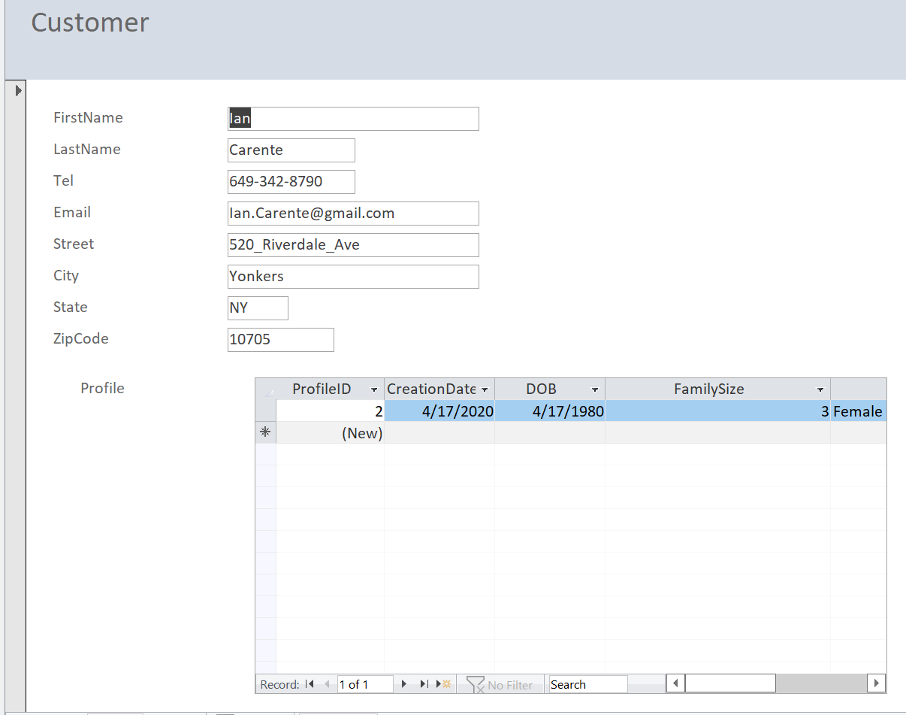

**Supplier Form** is for the suppliers BlueWaters has partnered with. They can fill out the form online with their company details and the type of service they offer.

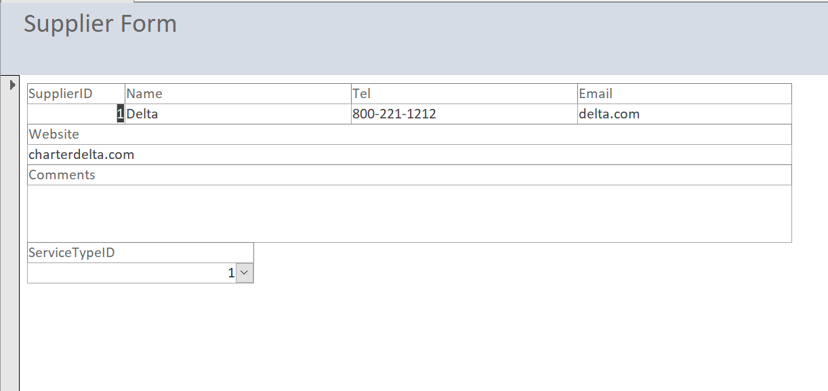

**The Navigation Form** includes all the key forms required for the core business.

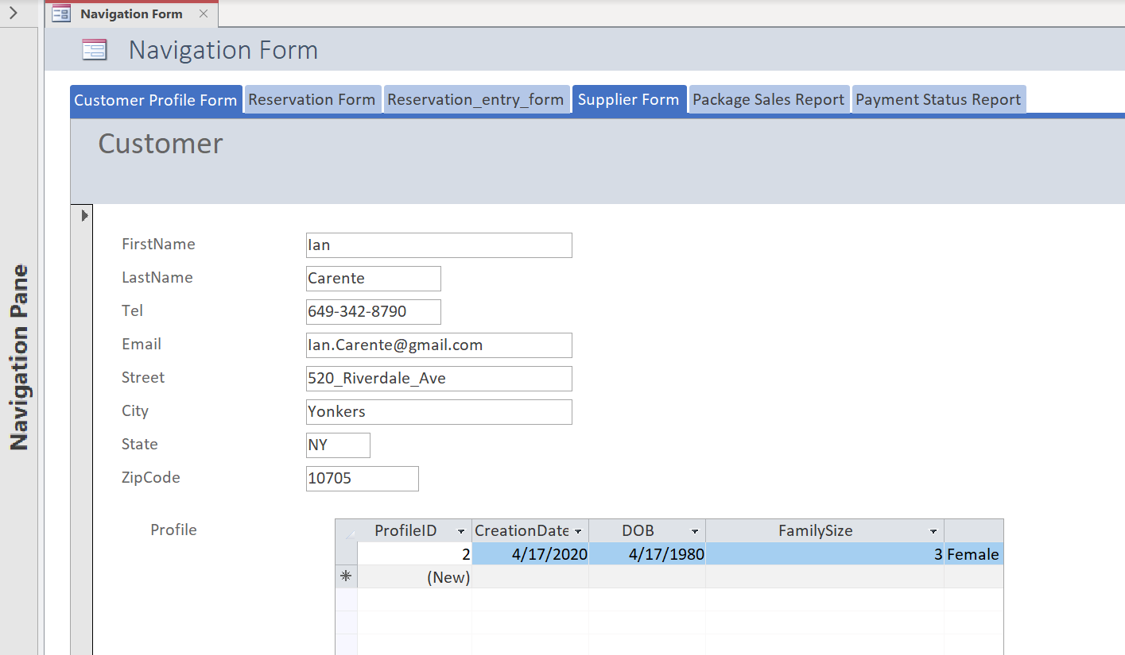

### Reports

**Payment Status Report** keeps track of the customers who paid in full and also shows what payment method they used to pay for the package.

This report will help the company to better assist the customers or reach out to them by looking at their payment status.

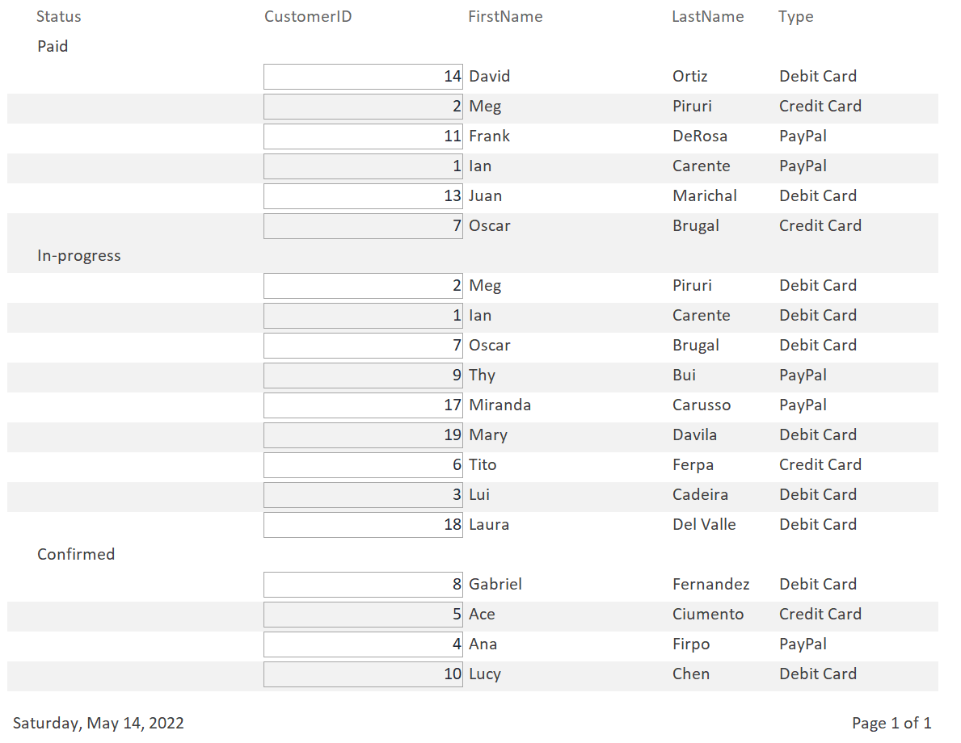

**Package Sales Report** shows the price and the total sale for each package. This will help BlueWaters to determine if the price is affecting the popularity of their packages and help the company make informed decisions based on that.

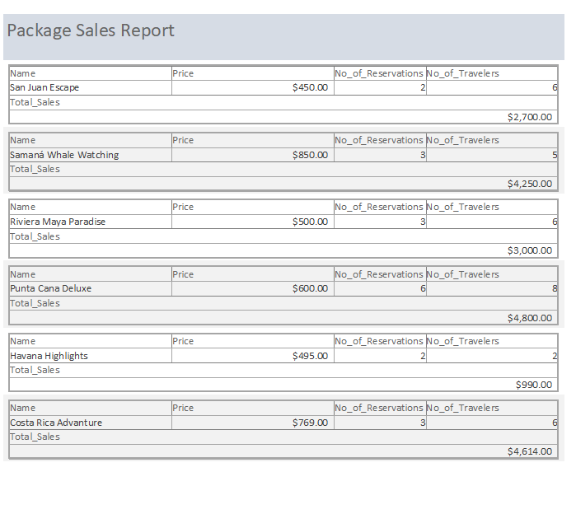

### 

### Queries

BlueWaters has been growing and has the need to tap into the right market, we query our data to break down our sales by packages, family size, gender, city, and customer.

**Query 1:** *Sale/Reservations by Packages*

Our Punta Cana Deluxe is the top-selling package with $3600 over the past month, followed by Samana Whale Watching and Riviera Maya Paradise package with $2550, and $2307.

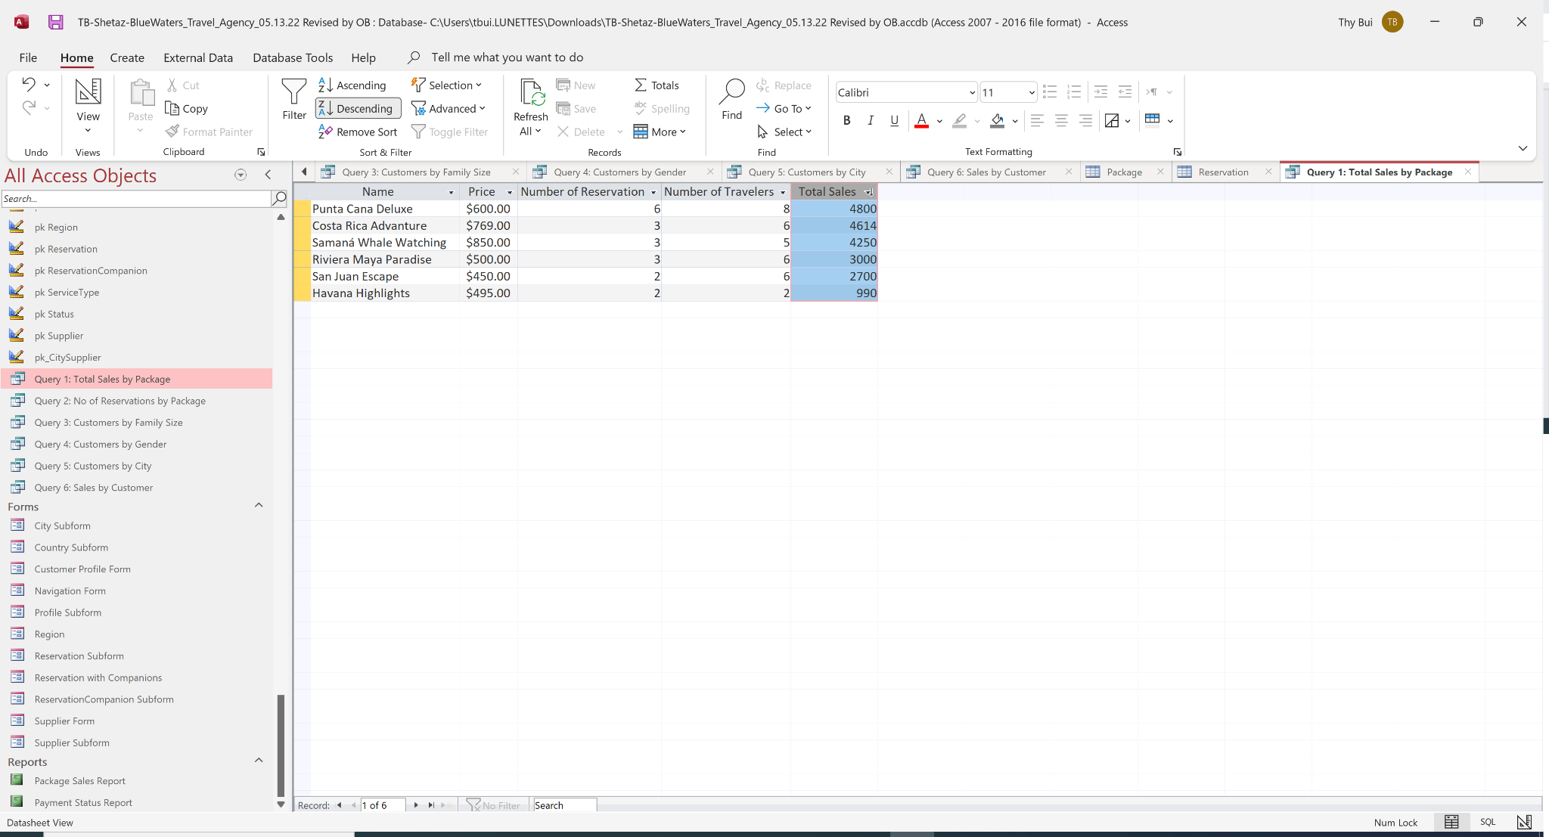

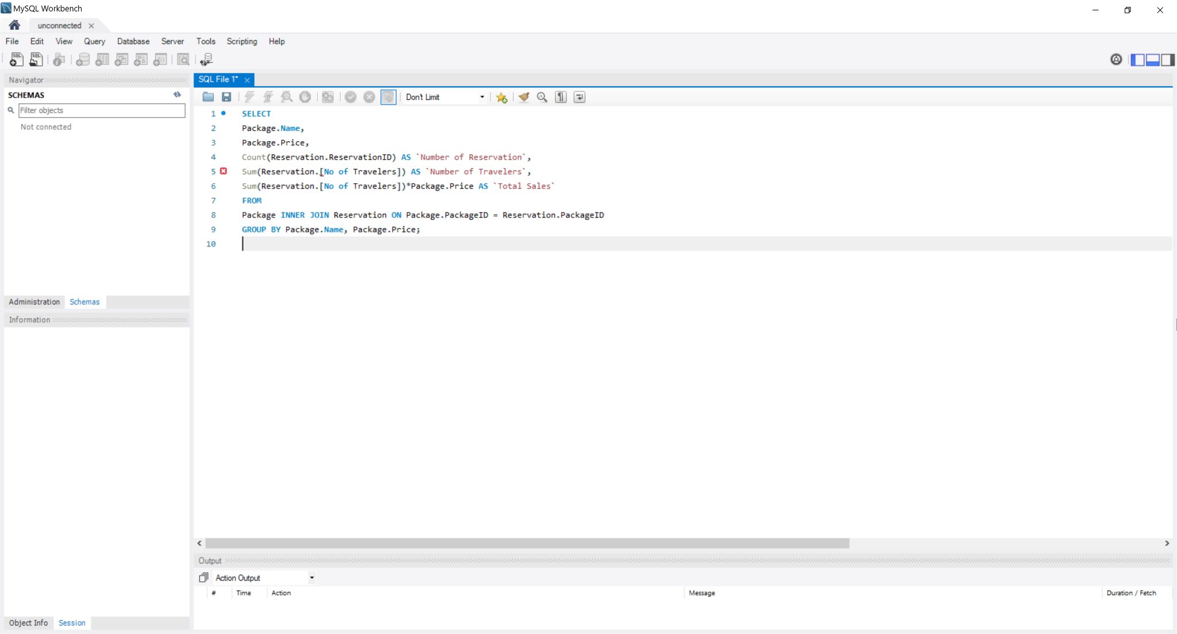

**Query 2:** *Customer by Family size*

We found out 38% of our clients are single people.

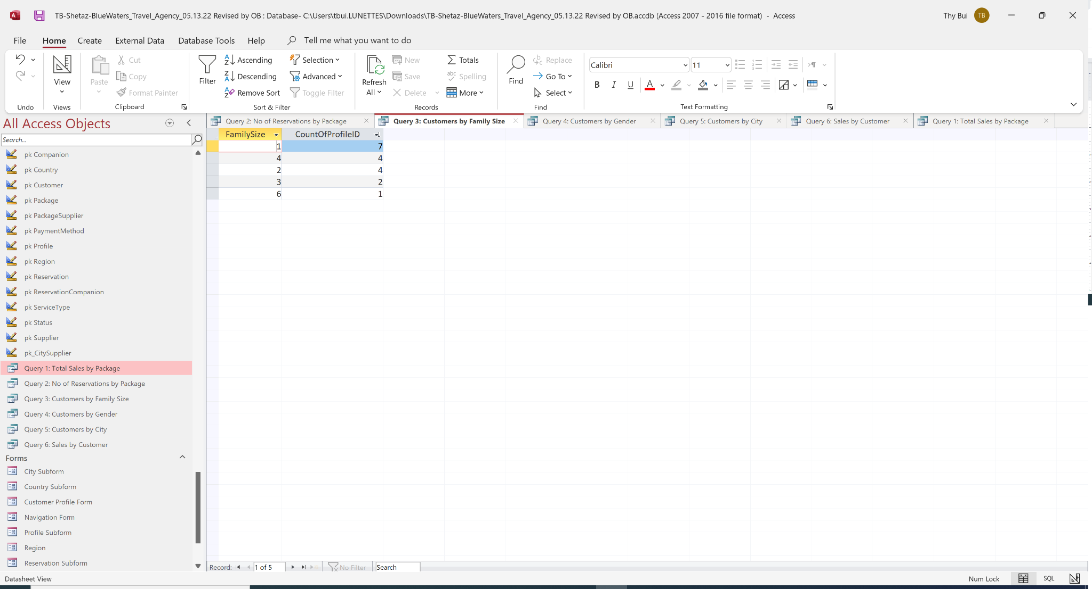

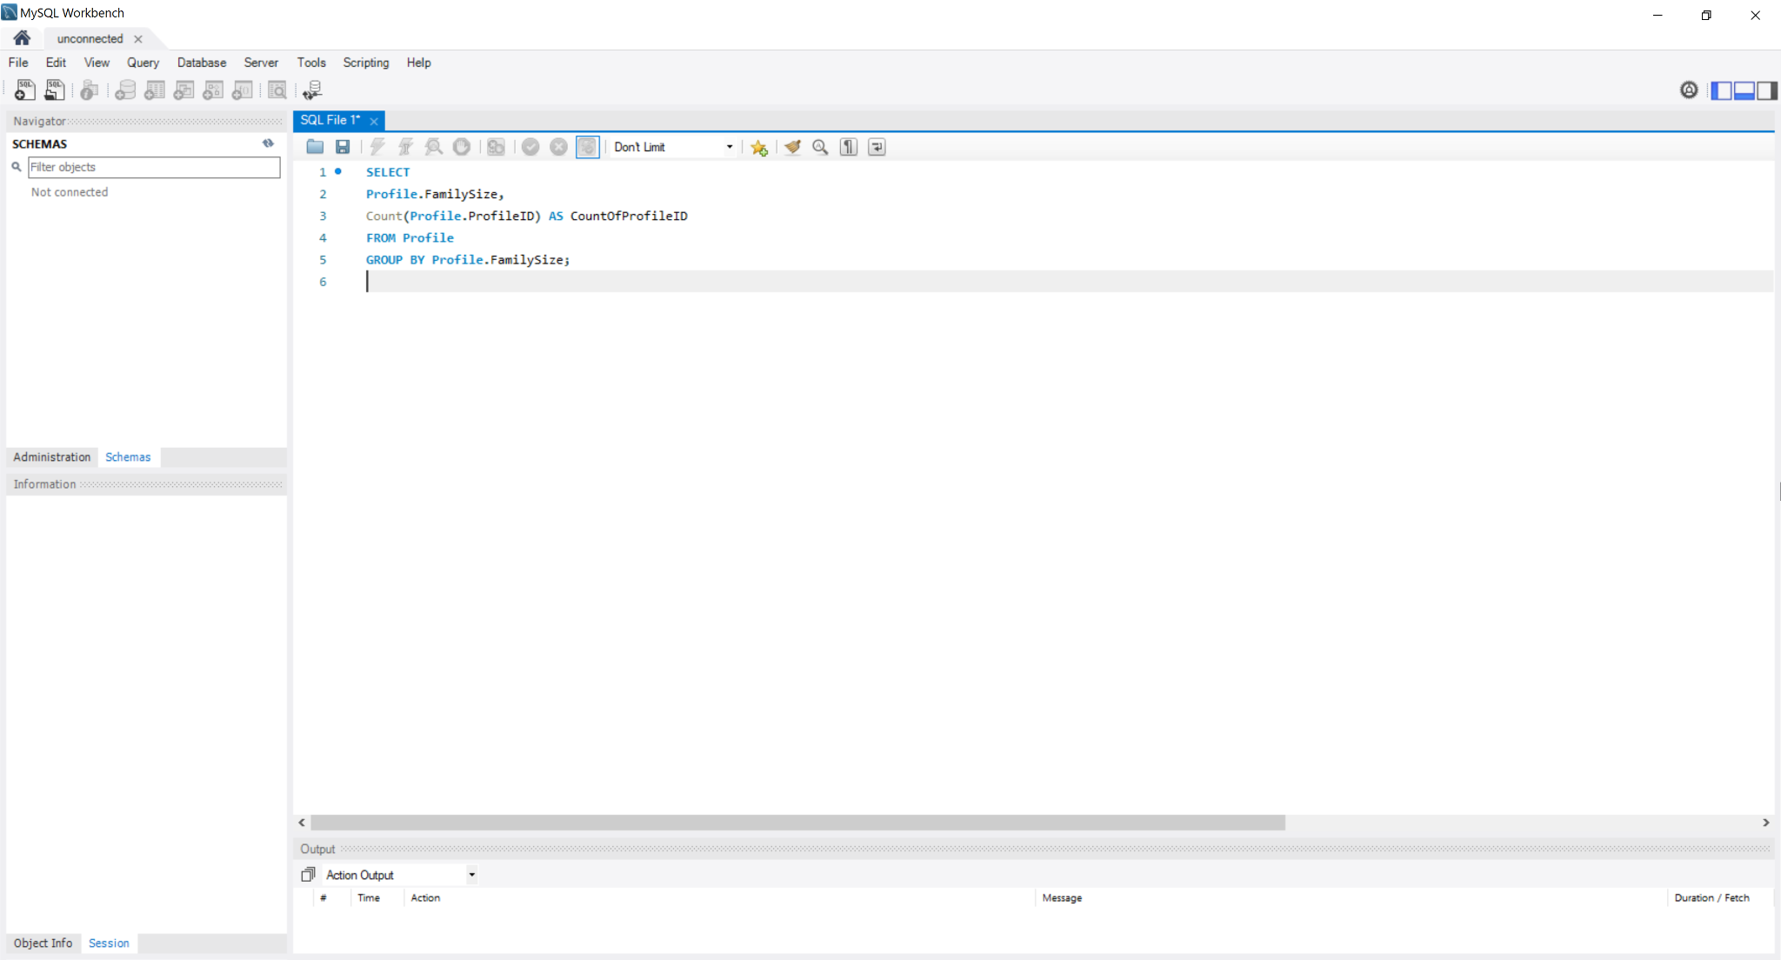

**Query 3:** *Customer by Gender*

We found that our service attracted a slightly bigger number of females than males.

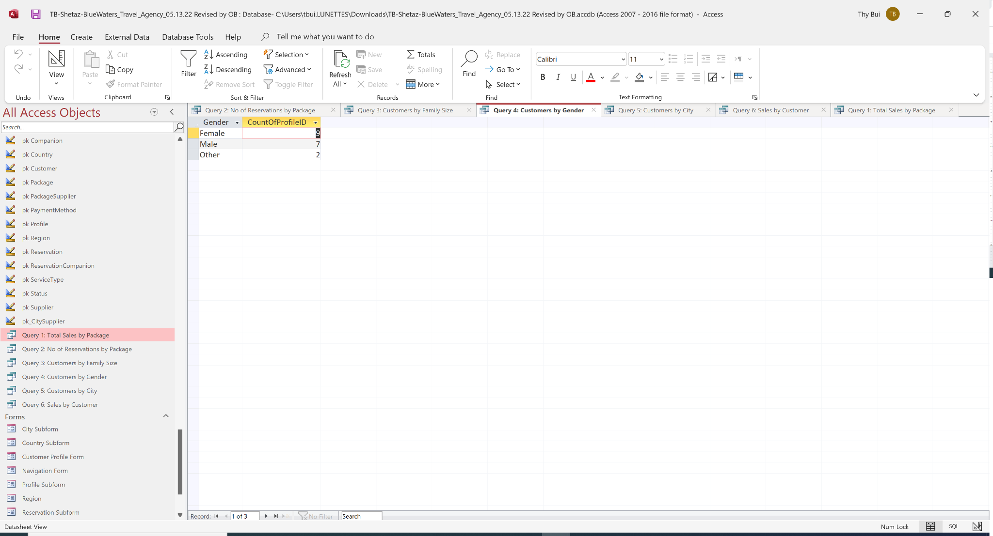

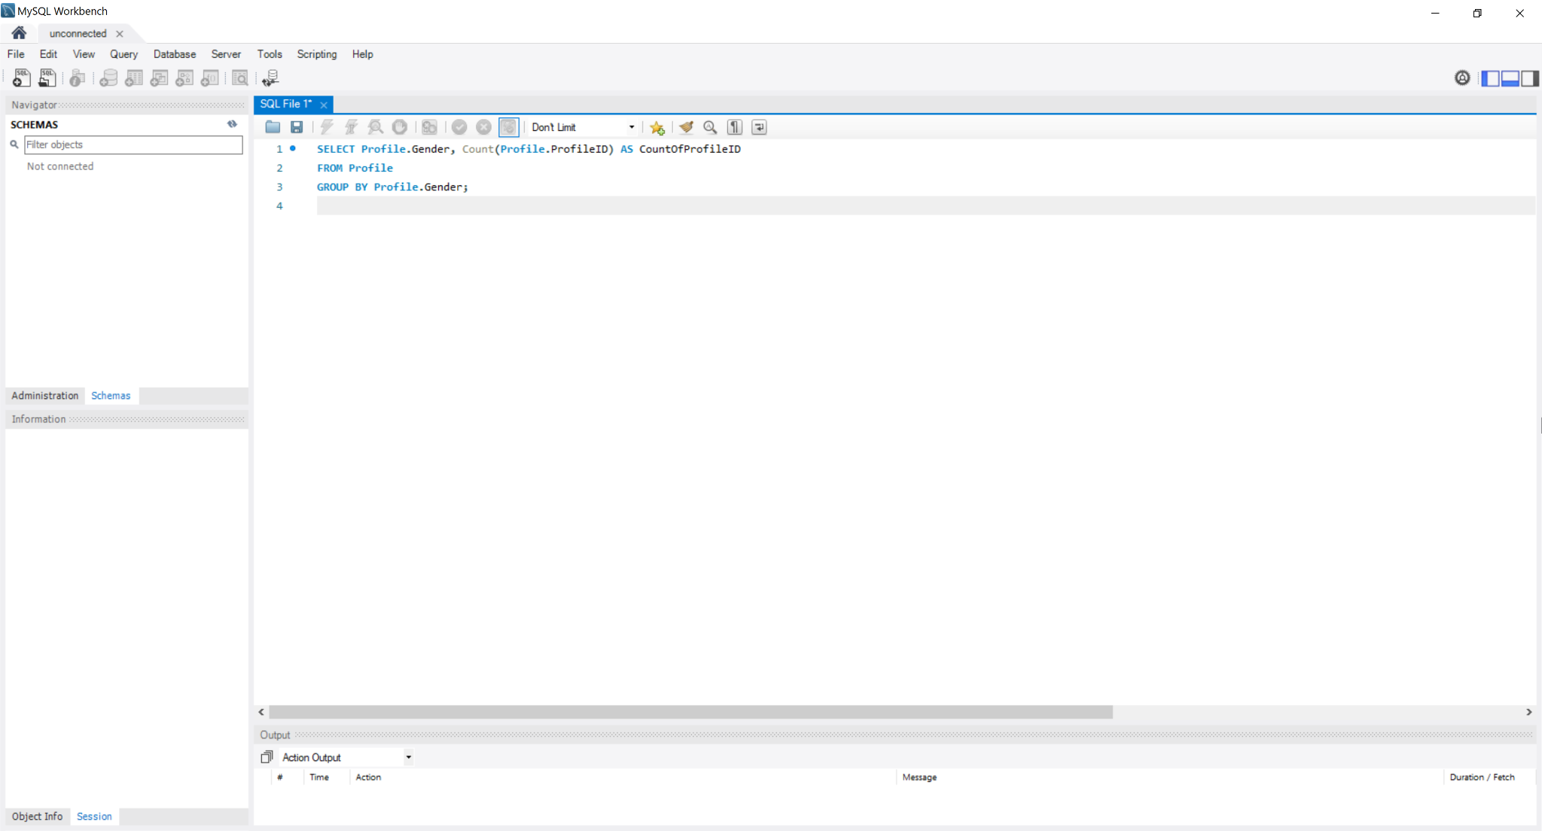

**Query 4:** *Customers by City*

We found out that New York and Brooklyn residents favor our service, the other boroughs are targets we want to expand to.

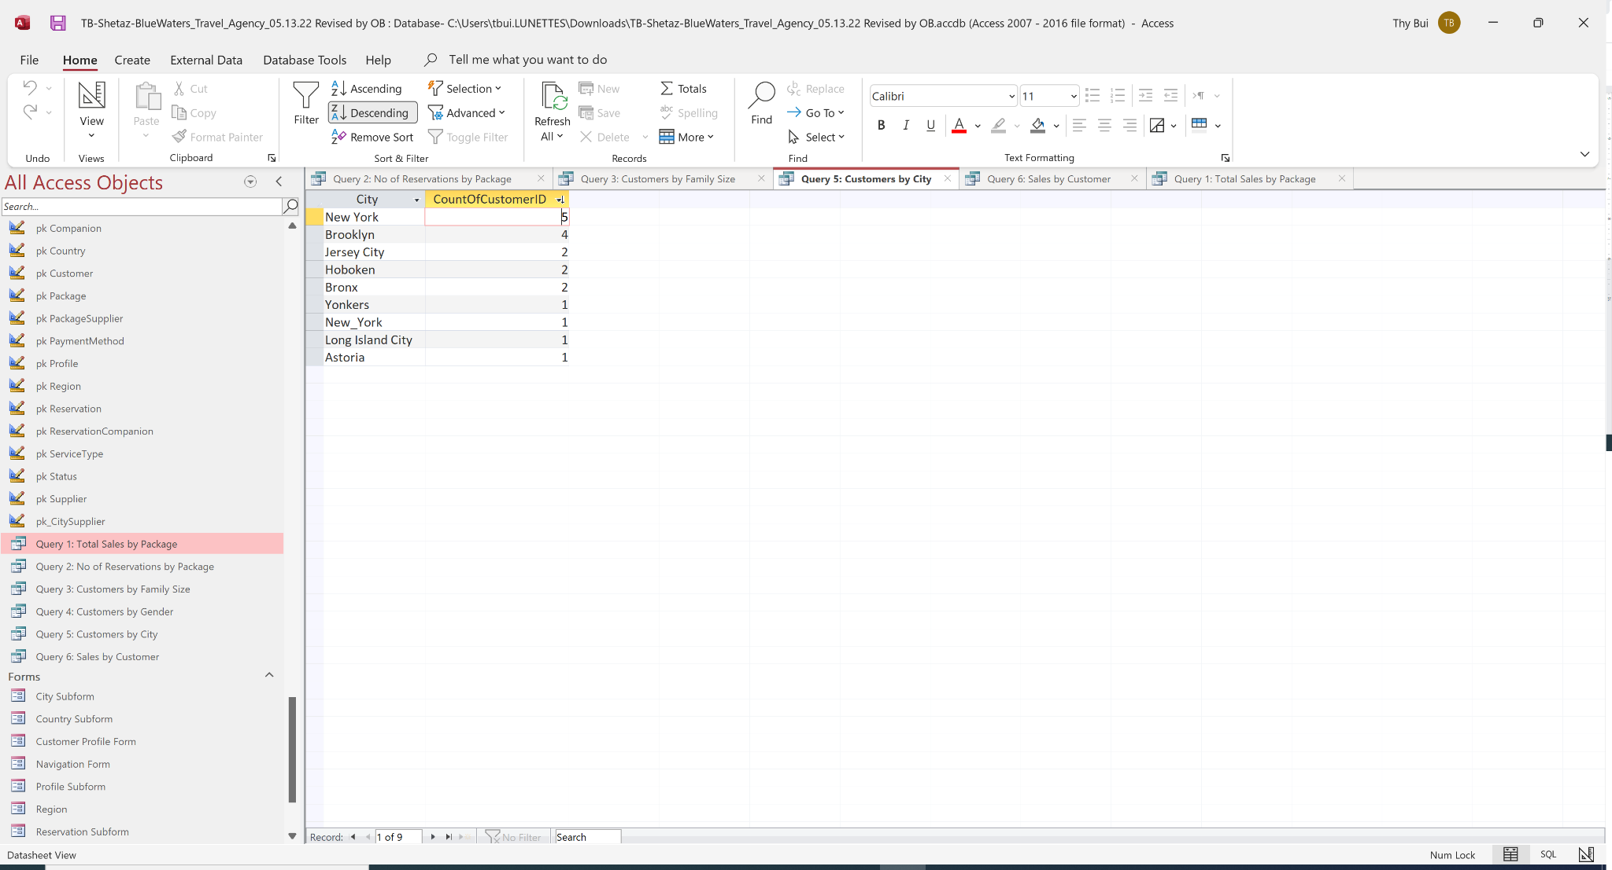

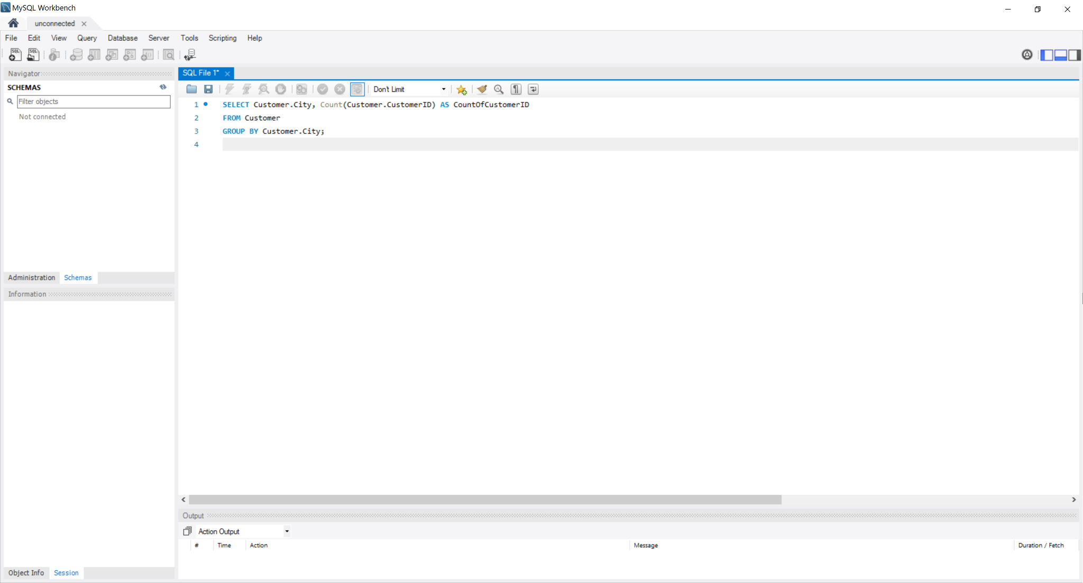

**Query 5:** *Sales by Customer*

This query is to look at loyal customers. We have several loyal customers and attract quite a big amount of new clients.

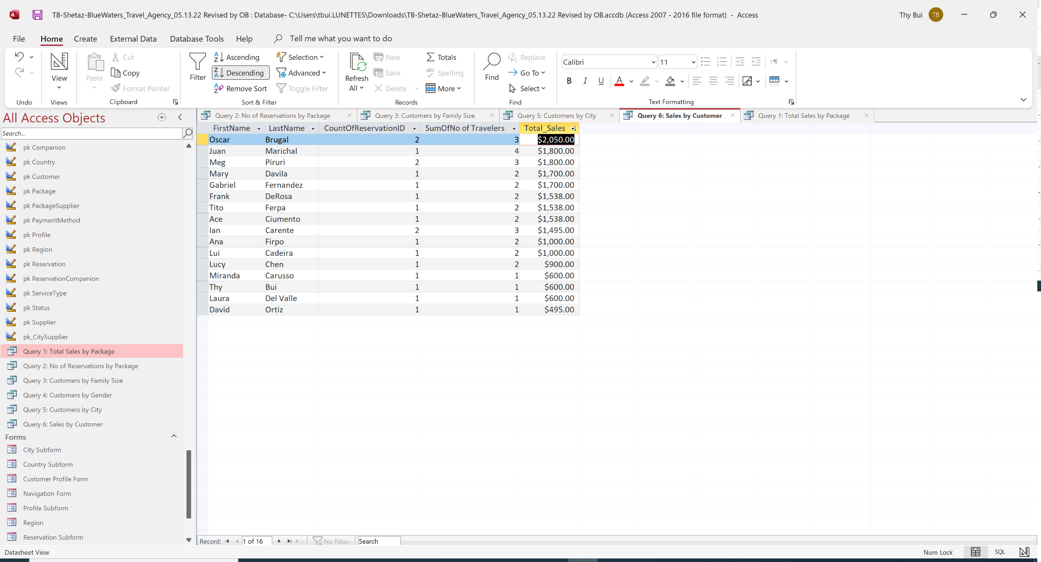

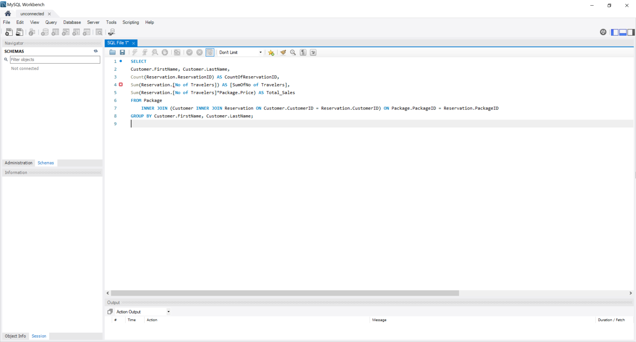

## Part 6: Narrative Conclusion

### a) The group's experience with the project

Working in such a large project with 6 people - most of who are working/studying full time - was certainly challenging. Having to coordinate weekly meetings and figuring out how to manage the workload across the team were some of the main issues we faced. It was really helpful to have an open line of communication and coordinate weekly meetings during the week and after class. Given that every change that we made in the database affected every area of the project it was really helpful to give each team member ownership over the different steps of the project to ensure the database and documentation was consistent across the board.

In relation to the project itself, we believe this was a great way to put our knowledge into practice and get a better understanding of the topics discussed in class. We learned to put business requirements into technical models, build a database that can transform into helpful information for the business. We understand it is a challenge to bring pieces of business operations into the models.

### b) If the proposed benefits can be realized by the new system

In summary, yes. We have built a functional database that can help us build reports that break down sales. Furthermore, we can analyze the business’ strengths and opportunities by querying the data.

### c) Any final comments and conclusions

Our experience with the project shows us that designing a database is a dynamic process. While we followed the stages as learned in class, many times we had to update the previous stages whenever we made an important change. This was particularly common in the ER, Logical, and Physical modeling. For instance, we ended up creating 5 versions of the ER modeling.

In addition, we had the chance to experience the trade-off between normalization and usability that was discussed in the book. For instance, we found out that it was easier to create forms, reports, and queries for the tables that were not highly normalized like “Customer” and “Profile”. On the other hand, the tables that we highly normalized like “Reservation” require us to perform many joins on the backend to create a user-friendly form or report such as a Reservation form and Sales report.

## Appendix A: Meeting Logs

**Group Meeting Log Sheet 1**

**Date of Meeting:** 03/31/2022  **Time of Meeting:** 7:45 pm

**Group:** 4  **Recorder:**  Frank

**Attending:** Gabriel, Shetaz, Thy, Lucy, Frank, Oscar

Topics Discussed:

* Reviewed individual contributions and feedback regarding each component of the Project Proposal.
* Discussed big picture vision for the premise of the business. Then considered how the eventual user requirements would align with the problem facing this business and the solution we are proposing.
* Conceived roles to distribute duties for the project.
* Delegated remaining tasks in order to create a final deliverable for Professor’s review.

| **Tasks Assigned** | **Team Member** | **Delivery Date** |
| --- | --- | --- |
| Contribute independent ideas to address the Project Proposal | All | 03/31 |
| Synthesize team notes to draft Project Proposal | Gabriel | 04/01 |
| Analyze draft Proposal and provide feedback | Lucy, Frank | 04/01 |
| Review latest draft Proposal and finalize for submission | Thy | 04/02 |

**Meeting Ending Time:** 8:45 pm

**Group Meeting Log Sheet 2**

**Date of Meeting:** 04/03/2022  **Time of Meeting:** 5:05pm

**Group :** 4  **Recorder:**  Shetaz

**Attending:** Gabriel, Oscar, Shetaz, Thy and Lucy, Frank

Topics Discussed:

* Went over the different business problems, each targeting a specific sector and voted for option 2 that focuses both on the core business and tracking customer preferences.
* Discussed if we should focus on only one service like flight but then agreed it will be more comprehensive to have all the services included
* Decided to have at least two meetings during the week. Thursday evening via zoom and Saturday after class

| **Tasks Assigned** | **Team Member** | **Delivery Date** |
| --- | --- | --- |
| Draft ER Diagram | Oscar, Thy | 04/07 |
| Write business requirements | Shetaz | 04/07 |
| Refine ER modeling and relationship sentences | Gabriel, Lucy | 04/08 |
| Produce the final deliverable | Frank | 04/09 |
|  |  |  |

**Meeting Ending Time:** 5:48 pm

**Group Meeting Log Sheet 3**

**Date of Meeting:** 04/09/2022  **Time of Meeting:** 4:45 pm

**Group:** 4  **Recorder:**  Frank

**Attending:** Gabriel, Oscar, Thy, Lucy, Frank, Shetaz

Topics Discussed:

* Reviewed the latest draft of the E-R diagram as a team and gathered feedback.
* Considered how our modeling now might be influenced by future steps, including normalization.
* Noted areas in our E-R diagram that could be updated for the sake of clarity and simplicity.

| **Tasks Assigned** | **Team Member** | **Delivery Date** |
| --- | --- | --- |
| Draft version 3 of the E-R diagram (focusing on entity tables) | Oscar, Thy | 04/11 |
| Finalize E-R model (focusing on relationships) | Shetaz, Gabriel, Frank | 04/13 |
| Set up Final Report and Access deliverable files | Lucy, Frank | 04/13 |
| Produce the final deliverable | Frank | 04/14 |

**Meeting Ending Time:** 5:30 pm

## 

## Appendix B: Group Team Project Participation

**Group 4**

| *Tasks Assigned* | *Team Members* |
| --- | --- |
| **Project Proposal** | Everyone participated |
| **Systems Analysis / ER Modeling** |  |
| **Systems Analysis** | Shetaz |
| **ER Modeling** | Oscar |
| **Logical & Physical Modeling** |  |
| **Logical Modeling** | Gabriel |
| **Normalization** | Gabriel |
| **MS Access Tables** | Lucy |
| **Relationships** | Lucy, Gabriel, Oscar |
| **Queries** | Thy |
| **Reports** | Shetaz |
| **Forms** | Shetaz |
| **Conclusion** | Everyone participated |
| **Final Report** | Lucy, Frank |
| **Powerpoint Presentation** | Frank |
| **Project Manager** | Frank |

​​

## Appendix C: Reference

* Logo template: [Freepik.com| Plane with palms icon logo of travel and travel agency vector illustration](https://www.freepik.com/premium-vector/plane-with-palms-icon-logo-travel-travel-agency-vector-illustration_25050807.htm)